QUESTION 1

(a) Problem Description
During examination periods, college and university students face significant pressure attempting to build and manage study schedules. Most students take between 5 to 7 modules in a semester, each with different levels of difficulty, broad syllabus and unevenly spaced exam dates.

Who suffers from this problem?
Tertiary students across all disciplines suffer from this problem, particularly those taking technical and heavy workload programs where multiple complex exams are written over short periods.

How often does it happen?
This issue recures at least twice every academic year during mid-semester tests and final examination sessions, usually lasting several weeks.

Why is it worth solving?
Creating a study timetable manually using paper or standard spreadsheets is time-consuming and rigid. If an unexpected event occurs such as illness, an emergency, or an unexpected delay a static paper timetable becomes outdated immediately. As a result, students often resort to last minute cramming or spend too much time studying familiar, easier subjects while neglecting harder ones. An automated timetable generator solves this by dynamically calculating subject priorities and distributing study slots based on difficulty and time remaining before each exam.

(b) Proposed Solution
The proposed solution is an Adaptive Revision Timetable Generator. It is an algorithmic tool that constructs a custom, balanced study schedule for students leading up to their exams.

What would it do?
The system takes student input including the list of enrolled modules, the exact date for each exam, a self assessed difficulty rating for each module on a scale of 1 to 5 and the total available daily study hours. Using this information, the algorithm calculates a priority weight for each subject based on its difficulty and how soon the exam takes place. It then assigns daily study sessions into designated time blocks while applying practical constraints , limiting continuous study on a single module to a maximum of 2 hours per day to prevent exhaustion, inserting rest intervals, and recalculating the schedule if study sessions are missed.

Who would use it?
College students, high school students preparing for national final exams and self taught learners working through multiple certifications simultaneously.

(c) Current Approaches vs. Proposed Solution
Currently students manage their revision using paper planners, static calendar apps such as Google Calendar or informal daily decisions.
Paper planners are completely rigid, skipping one day renders the entire plan inaccurate. Standard digital calendar tools allow setting reminders, but they require manual entry for every session and do not contain domain specific logic to automatically balance subject difficulty against exam proximity.
My approach improves upon existing solutions by incorporating dynamic priority scoring and automated slot allocation. It mathematically evaluates which subject requires attention first and automatically adjusts future time slots whenever a student logs a missed or incomplete study block.

QUESTION 2

(a) Inputs, Outputs, and Assumptions
Inputs | modulesList | Array of records containing ModuleName (String), ExamDate (Date), and DifficultyRating (Integer from 1 to 5).
Category | Item Name | Data Type & Description
Inputs | dailyAvailableHours | Real number representing available study hours per day (e.g., 6.0).
Inputs | startDate | Date representing the first day of revision.
Outputs | timetableSchedule | Array of structured daily slots detailing Date, TimeSlot, ModuleName, and Duration.
Outputs | Subject Summary | Summary report displaying total study hours allocated per subject.
Assumptions | Fixed Exam Dates | 1. Daily available study hours remain consistent across the revision period.
Assumptions | Non-negotiable | 2. Exam dates are fixed and non-negotiable.
Assumptions | Cognitive Fatigue | 3. Maximum continuous study time for any single module on a single day is capped at 2.0 hours.

(b) Data Structure Choice & Justification
Chosen Data Structure: An Array of Records used to maintain module priority rankings, alongside an 1D Array of Daily Time Slots for the final generated schedule.
Justification:
To determine which subject should be assigned to an available study block, modules are evaluated using a Priority Score = (Difficulty Rating * 10) / Days Remaining Until Exam.
Using an Array of Records sorted by Priority Score (or a Max-Heap Priority Queue) allows the algorithm to immediately inspect and select the most urgent subject in O(1) time.
Compared to a Singly Linked List (the alternative considered) a linked list would require linear search traversal O(N) across all modules every time a study slot needs filling. For N modules and M available time blocks a linked list approach results in O(N * M) operations. Sorting an array or maintaining a heap allows instantaneous look ups and efficient updates, making it far better suited for multi-subject timetable generation.

(c) Flowchart / Block Diagram using Draw.io
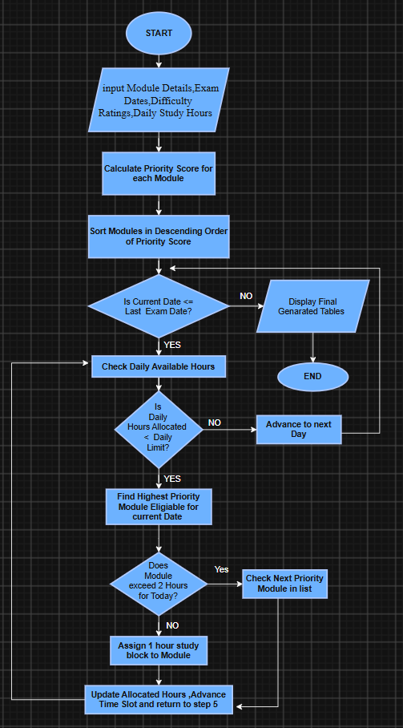

QUESTION 3

(a) Pseudocode for MAIN Algorithm
ALGORITHM GenerateRevisionTimetable
INPUT:
modules: Array of Module records (name, examDate, difficulty)
dailyHours: Real
startDate: Date
OUTPUT:
schedule: Array of StudySlot records (date, moduleName, duration)
BEGIN
// Step 1: Initialization
totalModules <- LENGTH(modules)
lastExamDate <- GetLatestExamDate(modules)
totalDays <- DaysBetween(startDate, lastExamDate)
maxSlots <- totalDays * DailySlotsCount(dailyHours)
schedule <- CreateEmptyArray(maxSlots)
// Step 2: Calculate Priority Score for each module
FOR i FROM 0 TO totalModules - 1 DO
daysRemaining <- DaysBetween(startDate, modules[i].examDate)
IF daysRemaining <= 0 THEN
daysRemaining <- 1
END IF
// Priority weight calculation (Difficulty divided by Days Remaining)
modules[i].priorityScore <- (modules[i].difficulty * 10) / daysRemaining
modules[i].allocatedHours <- 0
END FOR
// Step 3: Sort Modules by Priority Score (Descending Order)
CALL SortModulesByPriority(modules, totalModules)
// Step 4: Fill Time Slots Day by Day
currentDate <- startDate
slotIndex <- 0
WHILE currentDate <= lastExamDate DO
dailyAllocatedHours <- 0.0

WHILE dailyAllocatedHours < dailyHours DO
selectedModuleIndex <- -1
// Search for highest priority module that hasn't hit its daily limit
FOR m FROM 0 TO totalModules - 1 DO

IF modules[m].examDate > currentDate THEN
subjectHoursToday <- GetDailySubjectHours(schedule, currentDate, modules[m].name)
IF subjectHoursToday < 2.0 THEN
selectedModuleIndex <- m
EXIT FOR
END IF
END IF
END FOR
IF selectedModuleIndex != -1 THEN
// Allocate a 1-hour study session
schedule[slotIndex].date <- currentDate
schedule[slotIndex].moduleName <- modules[selectedModuleIndex].name
schedule[slotIndex].duration <- 1.0
modules[selectedModuleIndex].allocatedHours <- modules[selectedModuleIndex].allocatedHours + 1.0
dailyAllocatedHours <- dailyAllocatedHours + 1.0
slotIndex <- slotIndex + 1
ELSE
// If all active modules hit limits, assign a rest/break slot
schedule[slotIndex].date <- currentDate
schedule[slotIndex].moduleName <- "REST / REVISION BREAK"
schedule[slotIndex].duration <- 1.0
dailyAllocatedHours <- dailyAllocatedHours + 1.0
slotIndex <- slotIndex + 1
END IF
END WHILE
currentDate <- AddDays(currentDate, 1)
END WHILE
RETURN schedule
END ALGORITHM

(b) Pseudocode for Supporting Routine
ALGORITHM SortModulesByPriority
INPUT:
modulesList: Array of Module records
count: Integer
OUTPUT:
modulesList (sorted in-place descending by priorityScore)
BEGIN
// Bubble Sort algorithm customized for descending priority order

FOR i FROM 0 TO count - 2 DO
FOR j FROM 0 TO count - i - 2 DO
IF modulesList[j].priorityScore < modulesList[j + 1].priorityScore THEN
// Swap records
tempModule <- modulesList[j]
modulesList[j] <- modulesList[j + 1]
modulesList[j + 1] <- tempModule
END IF
END FOR
END FOR
RETURN modulesList
END ALGORITHM

